##ASSIGNMENT 1##

Flowchart + Java Program Questions

**1. Check Positive Number:**

* Task: Create a flowchart to check whether a number is positive.
* Next Step: Write a Java program that checks if a predefined number is positive using an if-else statement and prints the appropriate message.

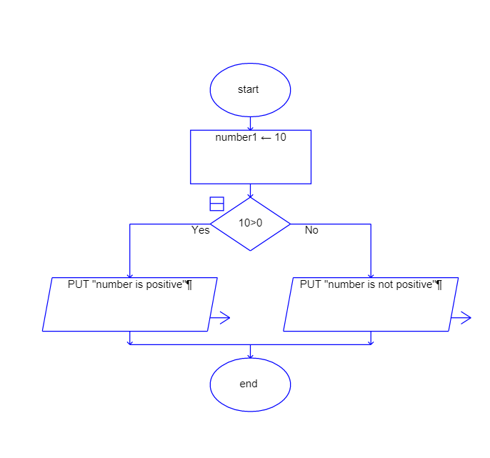

**Program:**

class PositiveNumbercheck {

public static void main(String args[]) {

int number = 10;

if (number > 0) {

System.out.print("number is positive");

} else {

System.out.print("number is not positive");

}

}

}

**2. Check Negative Number:**

* Task: Create a flowchart to check whether a number is negative.
* Next Step: Write a Java program that checks if a predefined number is negative using an if-else statement and displays the result.

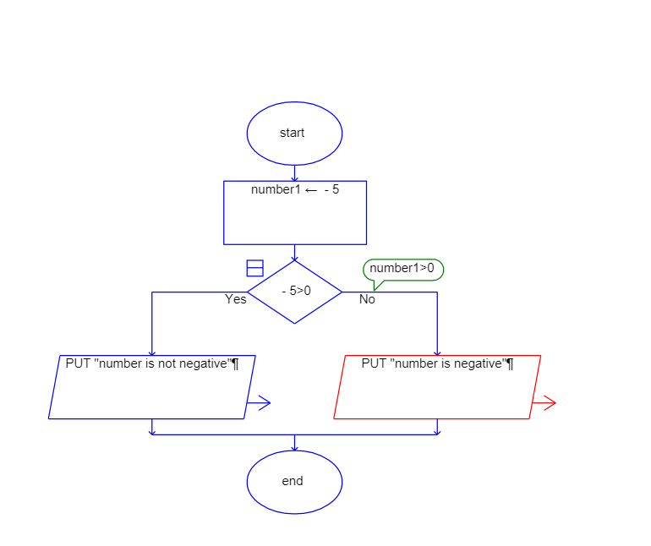

Program:

class NegativeNumbercheck {

public static void main(String args[]) {

int number = -5;

if (number > 0) {

System.out.print("number is not negative");

} else {

System.out.print("number is negative");

}

}

}

3**. Check Odd or Even Number:**

* Task: Create a flowchart to determine whether a number is odd or even.
* Next Step: Write a Java program that checks if a predefined number is odd or even. Use

an if-else statement and the modulus operator (%) to determine whether the number is divisible by 2 or not.

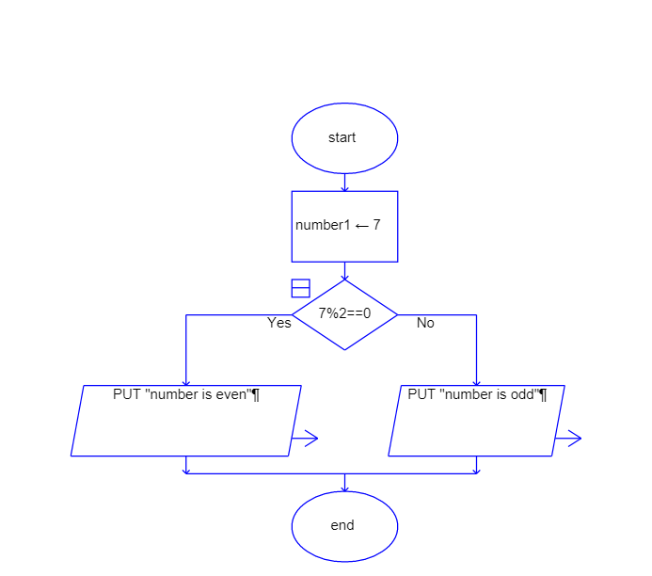

public class OddEvenNumber {

public static void main(String[] args) {

int number = 10;

if (number % 2 == 0) {

System.out.println(number + " is even.");

} else {

System.out.println(number + " is odd.");

}

}

}

**4 .Display Good Morning Message Based on Time:**

* Task: Create a flowchart to display a "Good Morning" message based on a given time.
* Next Step: Write a Java program that displays a "Good Morning" message if the

predefined time is between 5 AM and 12 PM. Use an if statement to implement the logic

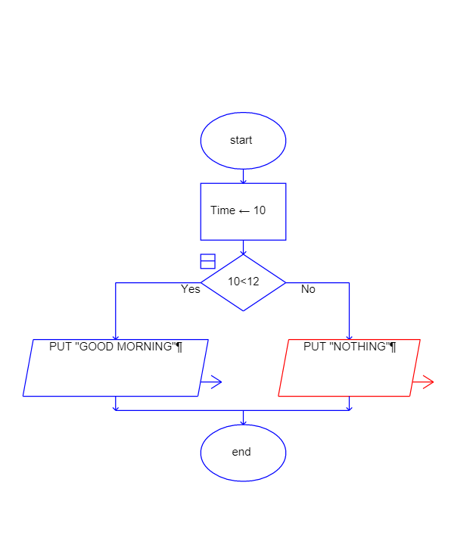

**Program:**

public class GoodMorningMessage {

public static void main(String[] args) {

LocalTime currentTime = LocalTime.now();

LocalTime startTime = LocalTime.of(5, 0);

LocalTime endTime = LocalTime.of(12, 0);

if (currentTime.isAfter(startTime) && currentTime.isBefore(endTime)) {

System.out.println("Good Morning!");

} else {

System.out.println("It's not morning time.");

}

}

}

**5 .Print Area of a Square:**

* Task: Create a flowchart to calculate and print the area of a square.
* Next Step: Write a Java program that calculates the area of a square using the formula

area = side * side. Use a predefined side length.

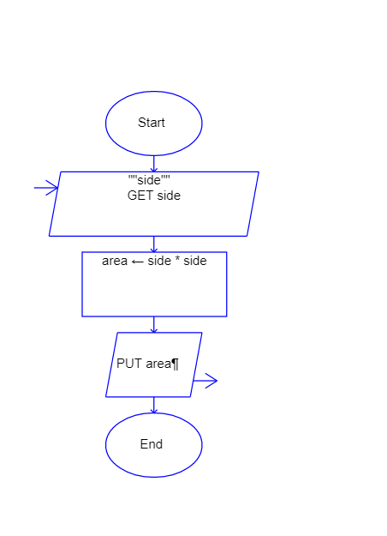

**Program**

class SquareArea {

public static void main(String[] args) {

int sideLength = 5;

int area = sideLength * sideLength;

System.out.println("The area of the square is: " + area);

}

}

**6. Print Area of a Rectangle:**

* Task: Create a flowchart to calculate and print the area of a rectangle
* Next Step: Write a Java program that calculates the area of a rectangle

area = length * width. Use predefined values for length and width.

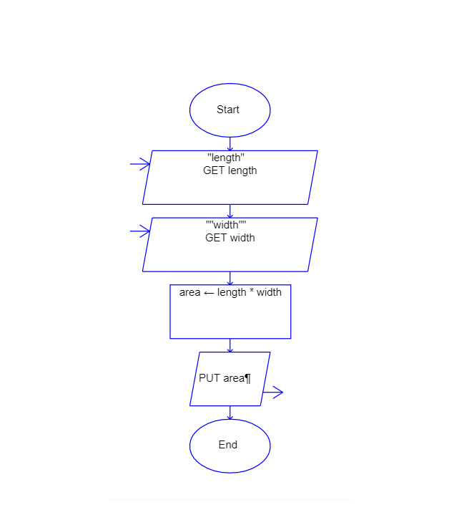

**Program**

class RectangleArea {

public static void main(String[] args) {

int length = 10;

int width = 5;

double area = length * width;

System.out.println("The area of the rectangle is: " + area);

}

}

**7.Find the Largest of Three Numbers:**

* Task: Create a flowchart to find the largest of three numbers.
* Next Step: Write a Java program that finds and prints the largest of three predefined

numbers using if-else statements.

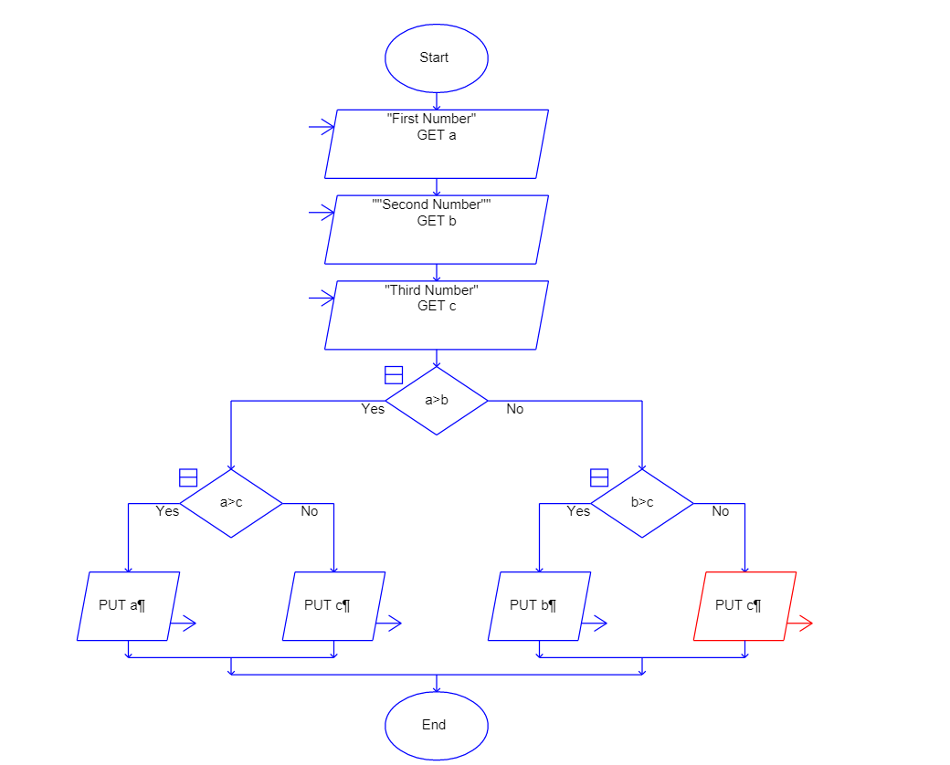

**Program**

class LargestNumber {

public static void main(String[] args) {

int num1 = 10;

int num2 = 25;

int num3 = 15;

int largest = (num1 >= num2 && num1 >= num3) ? num1

: (num2 >= num1 && num2 >= num3) ? num2

: num3;

System.out.println("The largest number is: " + largest);

}

}